DesignCTER

A User Guide

Kittpos Sirivongrungson

2024-08-03

Table of contents

# 1. Introduction

|  |
| --- |
| About |
| Welcome 👋, this is a user guide for [**DesignCTER**](https://design-cter.netlify.app), a cross-platform application for design CT protocols in emergency department. |

**Web App:** <https://design-cter.netlify.app>

**Desktop App:** please see [release in GitHub](https://github.com/Lightbridge-KS/designCTER/releases)

**Code:** [GitHub](https://github.com/Lightbridge-KS/designCTER)

## 1.1 Overview

This app consist of two modes in the bottom tab:

1. **Design:** Design CT Protocol (Figure 1.1)
   * Principle for design a CT protocol see Chapter 2.
   * Details for each protocols see Chapter 3.
2. **Calculate:** Calculators for commonly used formula in radiology (Figure 1.2)

## 1.2 Design Mode

|  |
| --- |
| Figure 1.1: Design Mode |

1. This mode will generate CT protocols available from 3 levels dropdown: “category”, “exam”, and “protocol”.
2. Other information can be filled in the input text field or checkboxes.
3. Once finished, user can press **Generate**, then the protocol will render accordingly in the output text field.

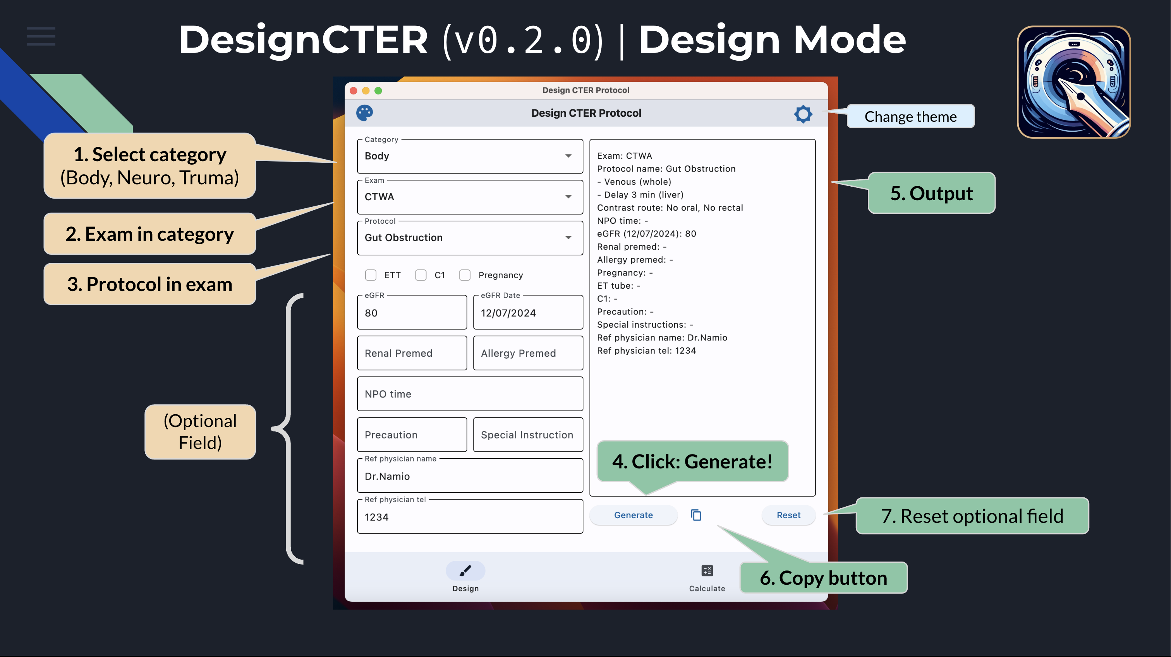

## 1.3 Calculator Mode

|  |
| --- |
| Figure 1.2: Calculator Mode |

This helper mode can be use as a calculator for writing radiology report which includes build-in calculator for common task, such as mean calculator (for calculate dose), prostate volume, and spine height loss.

### 1.3.1 Mean calculator

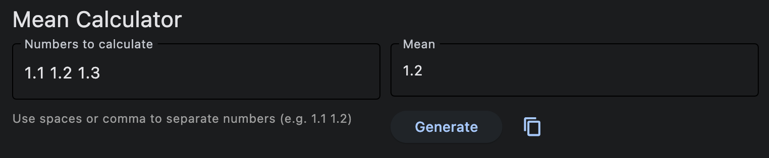

Mean Calculator

* To calculate mean value from any input numbers (separated by blank space or comma)
* **Usage example:** type 1.1 1.2 1.3 then press “Enter” or click “Generate”, the app will calculate mean values, which is 1.2.

### 1.3.2 Prostate volume

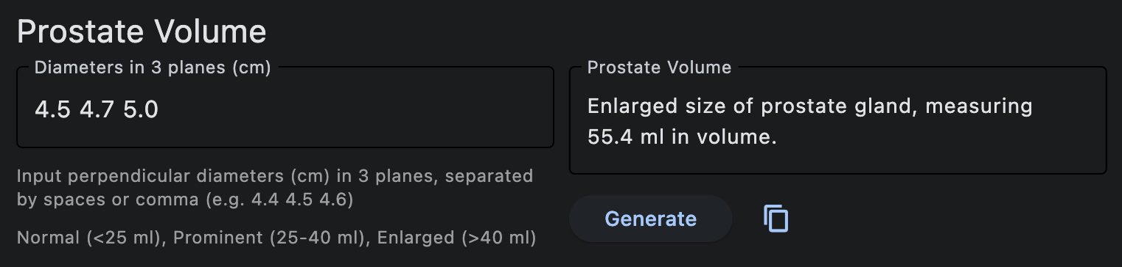

Prostate volume

* **Input:** Perpendicular diameter (cm) of prostate in 3 planes (separated by blank space or comma).
* **Output:** A report for prostate volume, using ellipsoid formula.
* **Usage example:** If diameter(s) of a prostate were 4.5, 4.7, and 5.0 cm in 3 planes:
  1. Type 4.5 4.7 5.0 in the textbox
  2. Press “Enter” or click “Generate”
  3. The app will calculate prostate volume and interpretation in the output dialog, which can be copied to report.

Interpretation of prostate volume was based on the following criterion:

* **Normal** (< 25 ml)
* **Prominent** (25-40 ml)
* **Enlarged** (> 40 ml)

|  |
| --- |
| Ellipsoid volume formula |
| $$\frac{4}{3}π×r_{1}×r_{2}×r_{3} \left(1.1\right)$$ Where $r_{1}$, $r_{2}$, $r_{3}$ are radius along 3 perpendicular axis, or $$\frac{1}{6}π×D_{1}×D_{2}×D_{3}≈0.5×D_{1}×D_{2}×D_{3} \left(1.2\right)$$   Where $D_{1}$, $D_{2}$, $D_{3}$ are diameter along 3 perpendicular axis. |

### 1.3.3 Spine Height Loss

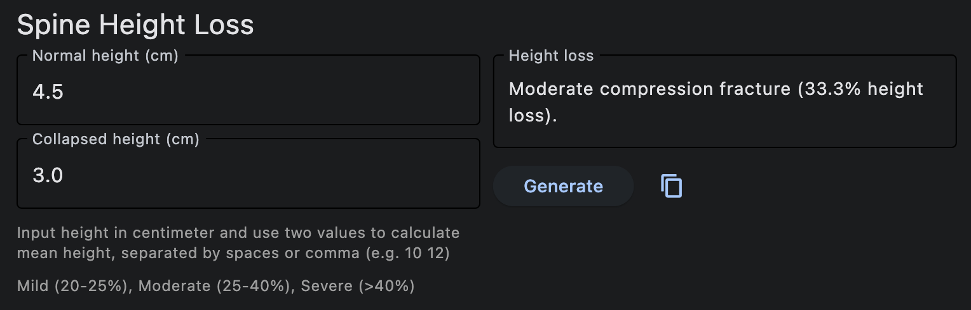

Spine height loss

* **Input:** Normal and collapsed height of spine. If there is no normal reference of the spine (e.g. severe collapse), the height of the two adjacent vertebrae can be used by input two numbers in the “Collapsed height (cm)” textbox (separated by blank space or comma).
* **Output:** A report for percentage of vertebral compression fracture with grading (mild, moderate, severe) using [Genant’s classification](https://radiopaedia.org/articles/44227).

**Usage example:** If Normal height = 4.5 cm, Collapsed height = 3.0 cm

1. Type 4.5 in “Normal height” and 3.0 in “Collapsed height” textbox
2. Press “Enter” or click “Generate”
3. Percentage of height loss and severity will be calculated, in this case:

$$\text{Height loss}=\left(4.5−3.0\right)×100/4.5=33.3\%$$

Which is moderate height loss according to [Genant’s classification](https://radiopaedia.org/articles/44227).

|  |
| --- |
| Genant’s classification |
| * Grade 0: Normal * Grade 1: Mild loss of height (20-25%) * Grade 2: Moderate loss of height (25-40%) * Grade 3: Severe loss of height (> 40%) |

# 2. Principles

The protocols used in this application were adapted from Ramathibodi emergency radiology handbook [1].

## 2.1 Steps

Here are the general tips for selecting appropriate protocols.

### Step 1: Select Protocols

Select appropriate study protocols based on *clinical question* of the referring physician. For complex clinical scenario, the protocols (including phases of scan) may be selected to cover a broad range of possible disease processes, while balancing the radiation exposure risk.

### Step 2: Add some phase of scan

For certain condition, specific phase of scan may added for better visualization. For example:

* **Suspecting hypervascular tumor:**
  + For example: NMR-CT-HCC: neuroendocrine, melanoma, RCC, choriocarcinoma, thyroid HCC
  + Consider adding **late arterial phase (upper)**
* **Liver/kidney transplant**
  + To assess transplant-related complications which includes vascular or non-vascular causes
  + Consider adding **late arterial phase (liver or kidney transplant)**

### Step 3: Contraindication of Oral or Rectal Contrast

Check contraindication for administered oral or rectal contrast, these includes:

* **Oral contrast is not recommended** in the following cases:
  + Severe vomitting or unable to eat
  + Severe abdominal bloating
  + History of aspiration or swallowing difficulty
  + Multiple dilated, fluid-filled bowel loops from abdominal radiograph
* **Rectal contrast is not recommended** in the following cases:
  + Inability to control bowel movements or administer enema (e.g., poor consciousness, post-AP resection surgery, colostomy)
  + Immunodeficiency (e.g., HIV, immunocompromised hosts, neutropenia, undergoing CMT/RT or within one month after receiving such treatments)
  + LGIB
  + Severe bloating or severely dilated colon (e.g., Cecum diameter > 8 cm)
  + R/O Toxic Megacolon

### Step 4: Other consideration

**Plain Only:** There are a few cases where a plain study is performed in emergency abdominal cases:

* Stone
* Ruptured AAA
* Bowel perforation
* Mesenteric ischemia
* Biliary/pancreatic stone

# 3. Protocols

The protocols used in this application were adapted from Ramathibodi emergency radiology handbook [1].

## 3.1 Body CT

### 3.1.1 CTWA

| Protocol | Phase Design | Contrast |
| --- | --- | --- |
| Routine WA | * - Venous (whole) * - Delay (liver) | Oral (limited water), Rectal (water) |
| --- | * - Plain (whole) * - Late A (upper) * - Venous (whole) * - Delay (liver) | Oral (?), Rectal (?) |
| Solid Organ Rupture | * - Plain (whole) * - Late A (upper) * - Venous (whole) * - Delay (upper) | No oral, No rectal |
| Free Air | * - Plain * - Venous (may be) | Oral (positive), Rectal (positive) [If not stable -> no oral, no rectal] |
| GI Perforation | * - Venous * - Delay (liver) | Oral (limited positive), Rectal (positive) |
| Gut Obstruction | * - Venous (whole) * - Delay 3 min (liver) | No oral, No rectal |
| HBP mass/abscess (CTWA) | * - Plain (upper) * - Late A (upper) * - Venous (whole) * - Delay (upper) | Oral (limited water), No rectal |
| Kidney mass/abscess | * - Plain (KUB) * - Late A (upper) * - Venous (100 sec) * - Delay (KUB) | Oral (limited water), No rectal |
| GI Mass | * - Venous (whole) * - Delay (liver) | Oral (full positive), Rectal (water) |
| Diverticulitis | * - Venous (whole) * - Delay (liver) | Oral (limited water), Rectal (1 L, positive CM) |
| Pancreatitis | * - Plain (upper) * - Late A (upper) * - Venous (whole) * - Delay (upper) | Oral (limited water), No rectal |
| Intra-abdominal infection | * - Plain (whole) * - Late A (upper) * - Venous (whole) * - Delay (upper) | Oral (limited water), Rectal (water) |
| Leak-Fistula-Collection | * - Venous (whole) * - Delay (liver) | Oral (if Hx bowel resect -> full positive; If not -> limited positive), Rectal (positive) ? |
| CT Second look Abd (trauma) | * - Venous (whole) | IV contrast, Oral (full positive), Rectal (positive) |

### 3.1.2 CTA Whole Abdomen

| Protocol | Phase Design | Contrast |
| --- | --- | --- |
| GI Bleed | * - Plain (whole) * - CTA (whole) * - Venous (whole) * - Delay (whole) | No oral, No rectal |
| Mesenteric Ischemia | * - Plain (whole) * - CTA (whole) * - Venous (whole) * - Delay (whole) | Oral (limited water), Rectal (water) |
| AAA Rupture | * - Plain (whole) * - CTA (maybe ถ้ามีเวลา คนไข้ stable) * - Venous (maybe ถ้ามีเวลา คนไข้ stable) | No oral, No rectal |
| CTA Blunt Abdomen (trauma) | * - CTA (whole) * - Venous (whole) * - may be Delay (in injury site) | IV contrast, No oral, No rectal |
| CTA Penetrating Abd (trauma) | * - CTA (whole) * - Venous (whole) * - may be Delay (in injury site) *** วาง marker ตําแหน่งแผลด้วย | IV contrast, Oral & Rectal full positive (ถ้ามีเวลา) |

### 3.1.3 CT Upper Abdomen

| Protocol | Phase Design | Contrast |
| --- | --- | --- |
| Routine Upper Abd | * - Venous (upper) * - Delay (upper) | Oral (limited water), No rectal |
| HBP mass/abscess (Upper) | * - Plain (upper) * - Late A (upper) * - Venous (upper) * - Delay (upper) | Oral (limited water), No rectal |
| Biliary Stone | * - Plain (upper) * - Late A (upper) * - Venous (upper) * - Delay (liver) | Oral (limited water), No rectal |
| Adrenal mass/abscess | * - Plain (upper) * - Late A (upper) * - Venous (upper) * - Delay 3 min (upper) *** Check ภาพ +/- Delay 15 min (adrenal) | Oral (limited water), No rectal |

### 3.1.4 CT Lower Abdomen

| Protocol | Phase Design | Contrast |
| --- | --- | --- |
| Appendicitis | * - Venous 120 sec (L3 to pubic symphysis) | Rectal (Positive 1 L สวนถึง cecum), No oral |

### 3.1.5 CT KUB

| Protocol | Phase Design | Contrast |
| --- | --- | --- |
| Hematuria | * - Plain (KUB) * - Late A (Kidney) * - Venous (KUB) * - Delay (KUB) *** Check ภาพก่อนเลิก | Oral (limited water), No Rectal |
| Kidney mass/Abscess | *** If suspect renal mass → consider CTWA for staging   * - Plain (KUB) * - Late A (Upper) * - Venous (100 sec) * - Delay (KUB) *** Check ภาพก่อนเลิก | Oral (limited water), No Rectal |

In cases of suspected urothelial or renal tumor:

* The patient should have a full bladder before undergoing a CT scan.
* Consider clamping the Foley catheter or instilling NSS into the bladder for patients on continuous bladder irrigation (CBI).

### 3.1.6 CTA for PE

| Protocol | Phase Design | Contrast |
| --- | --- | --- |
| CTA for PE (ไม่ลากขา) | * - CTPA (chest) * - Venous (chest) | IV contrast |
| CTA for PE with DVT | * - CTPA (chest) * - Venous (chest, legs) | IV contrast |

### 3.1.7 CT Chest

| Protocol | Phase Design | Contrast |
| --- | --- | --- |
| Routine CT Chest | * - **maybe** plain (chest) * - Late A (chest) | IV contrast |
| Nodule/mass characterization | * - Plain (chest) * - Late A (chest) | IV contrast |
| Tracheobronchomalacia | * - Plain (chest, dynamic expiration) | No IV contrast |
| Dysphagia | * - Plain (chest) * - Venous (chest) | IV contrast, Oral (limited water) |
| CT esophagogram | * - Plain (Chest, reduced dose) ก่อนกิน CM * - จากนั้น กิน CM 1 cup (250 ml) ที่เตียง * - Venous (Chest) หลังกิน CM | Oral (Positive CM) |
| SVC Obstruction | * - Plain (Chest, reduced dose) * - Late A (Chest) * - Immediate delay (Chest) | IV contrast |

### 3.1.8 CT Chest + WA

| Protocol | Phase Design | Contrast |
| --- | --- | --- |
| --- | * - Plain (Chest + Whole abd) * - Late A (Chest + Upper abd) * - Venous (Whole abd) * - Delay (liver) | Oral (?), Rectal (?) |

### 3.1.9 CTA Chest

| Protocol | Phase Design | Contrast |
| --- | --- | --- |
| Hemoptysis | * - Plain (Chest) * - CTA (Apex to L2) → Systemic arterial phase * - Immediate delay (Chest) * - Note: L2 (Celiac Axis) ให้เห็น renal artery origin | IV contrast |
| CTA Chest (trauma) | * - CTA (Chest) * - Venous (Chest) | IV contrast, No Oral, No Rectal |

### 3.1.10 CTA Whole Aorta

| Protocol | Phase Design | Contrast |
| --- | --- | --- |
| Aorta first time | * - Plain (whole aorta) * - CTA (whole aorta) * - Immediate delay (whole aorta) | IV contrast |
| Aortic Dissection | * - Plain (whole aorta) * - CTA (whole aorta) * - Immediate delay (whole aorta) | IV contrast |
| AAA Post-op | * - Plain (whole aorta) * - CTA (whole aorta) * - Immediate delay (whole aorta) | IV contrast |

### 3.1.11 CTA Runoff

| Protocol | Phase Design | Contrast |
| --- | --- | --- |
| CTA Runoff | ขา → Aortic bifurcation to feet แขน → mid-heart to hands   * - Plain * - CTA * - Immediate delay | IV contrast |
| CTA Runoff (< 60 yr) | ขา → Aortic bifurcation to feet แขน → mid-heart to hands   * - CTA * - Immediate delay | IV contrast |

## 3.2 Neuro CT

| Exam | Protocol | Phase Design | Contrast |
| --- | --- | --- | --- |
| CT Brain (non-contrast) | --- | --- | No IV contrast |
| CTA Brain | Intracranial aneurysm | * - Plain, CTA, post-contrast (Brain) | IV contrast |
| CTV Brain | Venous Sinus Thrombosis | * - Plain, CTV, post-contrast (Brain) | IV contrast |
| CT Brain with Contrast | --- | * - Plain, post-contrast (Brain) | IV contrast |

## 3.3 Trauma CT

| Exam | Protocol | Phase Design | Contrast |
| --- | --- | --- | --- |
| CTA Chest | CTA Chest (trauma) | * - CTA (Chest) * - Venous (Chest) | IV contrast, No Oral, No Rectal |
| CTA Neck | CTA Neck (trauma) | * - CTA (brain, neck) COW to arch * - Post-contrast (brain) | IV contrast |
| CT Facial Bone (non-contrast) | CT Facial Bone (trauma) | * - CT Facial Bones (plain) with 3D reformats | No IV contrast |
| CT Orbit (non-contrast) | CT Orbit (trauma) | --- | No IV contrast |
| CTA Whole Abd | CTA Blunt Abdomen (trauma) | * - CTA (whole) * - Venous (whole) * - may be Delay (in injury site) | IV contrast, No oral, No rectal |
| CTA Whole Abd | CTA Penetrating Abd (trauma) | * - CTA (whole) * - Venous (whole) * - may be Delay (in injury site) *** วาง marker ตําแหน่งแผลด้วย | IV contrast, Oral & Rectal full positive (ถ้ามีเวลา) |
| CTWA | CT Second look Abd (trauma) | * - Venous (whole) | IV contrast, Oral (full positive), Rectal (positive) |

# References

[1] E.R. Ramathibodi, Emergency radiology handbook (2021), V20 ed., n.d.